**JNJ Invoice Tracking Report**

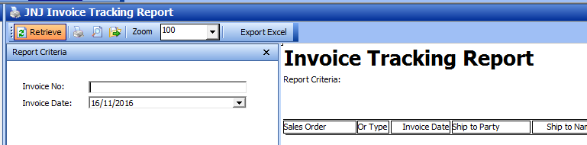

The current JNJ Invoice Tracking Report in WMS only allows data to be retrieved on a specific date or retrieve a specific invoice. Please add the following two options:

1. Retrieve invoices over a period of time like below



1. Retrieve invoices from a specific invoice no to another invoice no

There are large gaps in between the rows like below. The gaps aren’t supposed to be there (in red circle).

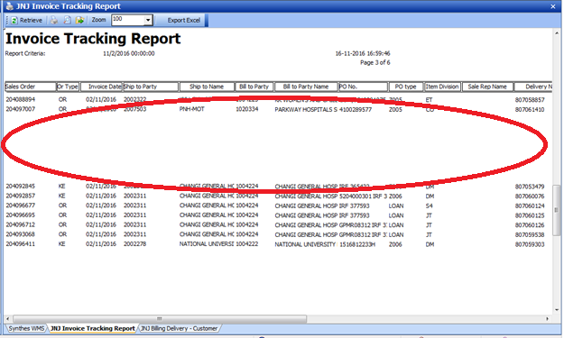

When the data is exported to an Excel, the gaps are also reflected in the report as highlighted yellow.

The data in the excel report aren’t in any particular sequence. Please edit the data extraction such that the data is in ascending order of the bill doc no (highlighted in green).

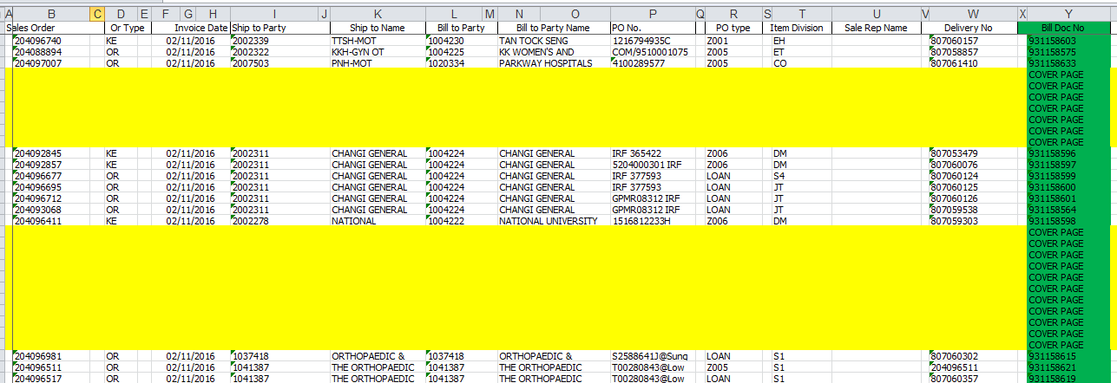

**JNJ Invoice Cover Page**

Please add a “Delete” and “Edit” button to the JNJ Invoice Cover Page like the ones in JNJ Orders Maintenance.

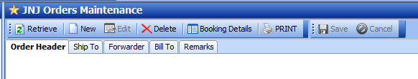

After the users edit a saved (and not finalized) invoice and then save and finalize it, he proceeds to create another cover page. However the tracking no has jumped (e.g. 0100 to 0102 instead of 0100 to 0101).

When an invoice is moved from the previous cover page to a new cover page, the system still shows that the invoice is linked to the previous cover page and not the new cover page.

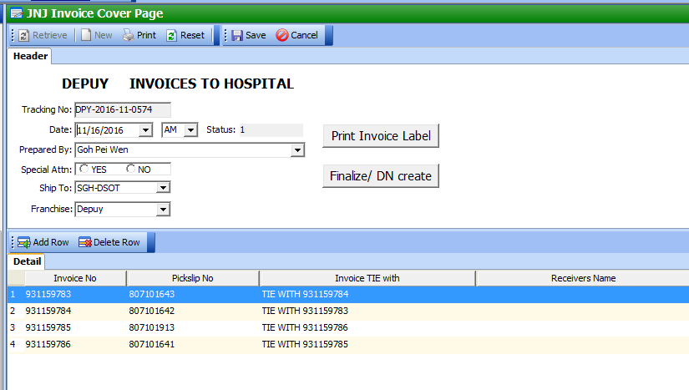

The current tracking no for the cover page is DPY-2016-MM-NNNN. When we enter a new month, the tracking no should start from DPY-2016-MM-0001. However, only the MM changes and the NNNN continue from the previous month.

Recently the users face the below error when they edit an unfinalized invoice cover page.

